**AIM:**

Program to implement linear and multiple regression techniques using any standards datasets available in the public domain and evaluate its performance.

**PROGRAM**

import pandas

from sklearn.datasets import load_boston

import pandas as pd

import matplotlib.pyplot as plt

df = pandas.read_csv("cars.csv")

X = df[['Weight', 'Volume']]

y = df['CO2']

from sklearn import linear_model

regr = linear_model.LinearRegression()

regr.fit(X, y)

#predict the CO2 emission of a car where the weight is 2300kg, and the volume is 1300cm3:

predictedCO2 = regr.predict([[2300, 1300]])

print(predictedCO2)

boston = load_boston()

plt.figure(figsize=(5, 4))

plt.hist(boston.target)

plt.title('car')

plt.xlabel('price ($1000s)' )

plt.ylabel('count')

plt.show()

**OUTPUT**

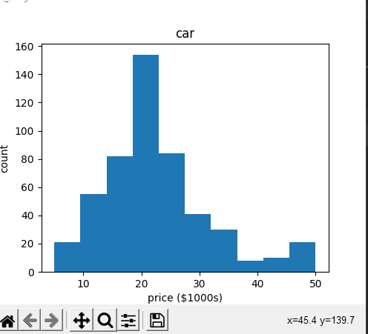

**PROGRAM**

import matplotlib.pyplot as plt

import numpy as np

from sklearn import datasets, linear_model, metrics

# load the boston dataset

boston = datasets.load_boston(return_X_y=False)

# defining feature matrix(X) and response vector(y)

X = boston.data

y = boston.target

# splitting X and y into training and testing sets

from sklearn.model_selection import train_test_split

X_train, X_test, y_train, y_test = train_test_split(X, y, test_size=0.4,

random_state=1)

# create linear regression object

reg = linear_model.LinearRegression()

# train the model using the training sets

reg.fit(X_train, y_train)

# regression coefficients

print('Coefficients: ', reg.coef_)

# variance score: 1 means perfect prediction

print('Variance score: {}'.format(reg.score(X_test, y_test)))

**OUTPUT**

Coefficients: [-8.95714048e-02 6.73132853e-02 5.04649248e-02 2.18579583e+00

-1.72053975e+01 3.63606995e+00 2.05579939e-03 -1.36602886e+00

2.89576718e-01 -1.22700072e-02 -8.34881849e-01 9.40360790e-03

-5.04008320e-01]

Variance score: 0.7209056672661767